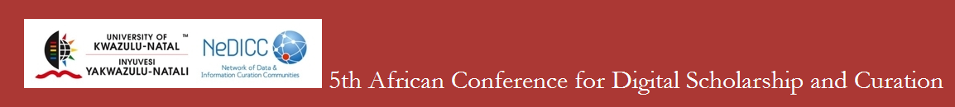
QUOTATION/REGISTRATION

TITLE: ………. fIRST NAME: ……………..………………….. last name: .………………………………………….….…………
aFFILIATION: .........................................................................................................................................
EMAIL: ………….…………………………………………………………………………………………………………………………………….
Registration Type | Cost
Early Bird |  | R3 000.00 ZAR (Closes 2013/05/25)
Registered and paid early bird registration fee of R3 000.00 (incl).
Proof of payment received before 25 May 2013.
Late Registration |  | R3 500.00 ZAR (Registration Opening 2013/05/26)
Registration and/or payment of R3 500 (incl) received after 25 May.
Student Registration |  | R2 000.00 ZAR (Closes 2013/05/31)
Registration and payment of R2 000 (incl) received on or before 28 June 2013.
Student registrations to be accompanied by a copy of valid student card.
REGISTRATION OPTIONS
Additional options are available at no extra cost. Select ONE from multiple workshop options.
Social Events |  |  | Attendance
Cocktail Reception, Wednesday 26 June
Y
Conference Dinner, Thursday 27 June
Y
Transport to Conference Dinner, Thursday 27 June
Y
Workshops Friday 28 June

Workshop A: Research Data Management for Rookies Time: 09:00 – 13:00

Workshop B: Mobile Apps Time: 14:00 – 16:30
Workshop C: Data Management and Publishing Time: 09:00 – 13:00
Workshop D: Governance Questions Time: 09:00 – 16:30
Workshop E: Data Management & Curation Time: 09:00 – 16:30

Once completed email to: adsc5@ukzn.ac.za

Account Name: University of KZN
Account Number: 053 080 998
Type of Account: Business Current Account
Branch Name: Westville
Branch Code: 045 426
Payment Reference: ADSC5 and Delegate Name

Submit proof of payment by fax or e-mail to Registration Manager
Mrs Preia Mudaly
E-mail: adsc5@ukzn.ac.za
Fax: +27(31)260-2125

